***Hawk 5***

Developed from Work Created by:

Louanne Clayton Jacobs and

Dee Dee Benefield Jones

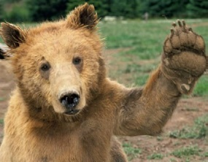

**Read Around the Word**



1. *Definition and*

*Restatement*

1. *Examples*
2. *Comparison*
3. *Contrast*
4. *Cause and Effect*
5. *Familiar Word Parts*

